**Social Buzz Content Category Analysis Report**

**Overview**

This report presents the findings from our analysis of Social Buzz's content categories. The goal was to identify the top 5 categories with the largest aggregate popularity and provide insights that could help boost user engagement on the platform.

**Data Summary**

* **Total Categories**: 16 unique categories
* **Example Categories**: Food, Science, Animals
* **Total Reactions in Animal Category**: 1897
* **Most Common Month for Posts**: January

**Key Findings**

**Top 5 Most Popular Categories**

The analysis identified the following top 5 content categories, ranked by aggregate popularity score:

1. **Animals**: 74,965
2. **Science**: 71,168
3. **Healthy Eating**: 69,339
4. **Technology**: 68,738
5. **Food**: 66,676

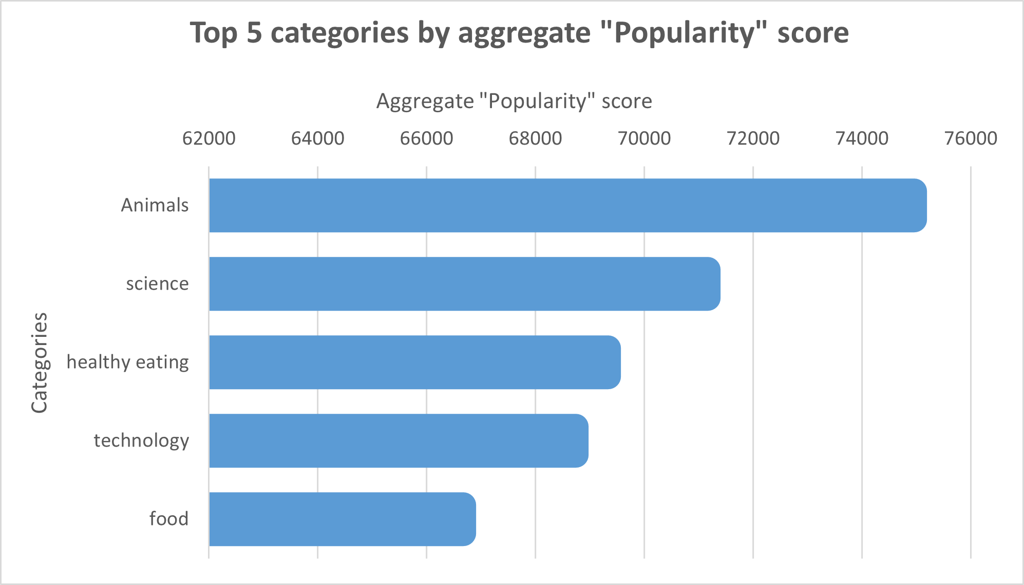

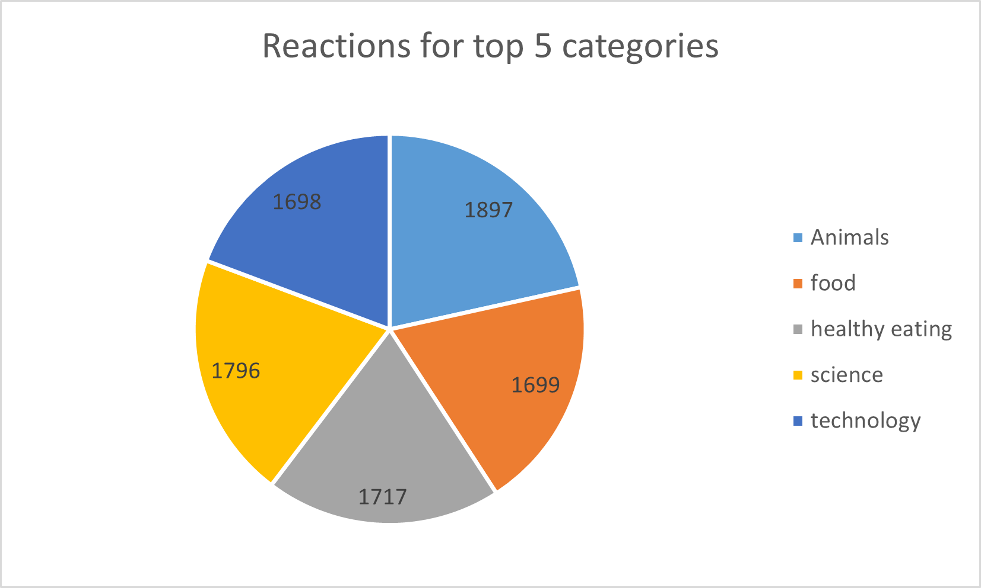

**Insights**

**Popularity of Animals**

* The animal category received the highest aggregate popularity score (74,965).
* With 1897 reactions from the animal category alone, it's evident that users have a strong affinity for animal-related content.
* This suggests that content featuring animals can significantly engage users.

**Seasonal Posting Trends**

* January emerged as the most common month for posts.
* This aligns with social media trends where users reconnect after calendar events like Christmas.

**Engagement with Food Content**

* Both "Food" and "Healthy Eating" categories are within the top 5.
* "Healthy Eating" ranks slightly higher than general "Food" (69,339 vs. 66,676).
* This indicates a potential skew towards health-conscious users on the platform.

**Interest in Science and Technology**

* The presence of "Science" and "Technology" in the top 5 suggests a user preference for factual and educational content.
* Users might enjoy learning new information and consuming educational snippets.

**Summary**

From our analysis, we identified the top 5 most popular categories: Animals, Science, Healthy Eating, Technology, and Food. Additionally, our findings suggest:

* **Animal and Science Content**: High user engagement with "real-life" and "factual" content.
* **Food Content**: Significant interest, particularly in "Healthy Eating", indicating a health-conscious user base.

**Recommendations**

* **Campaigns Focused on Popular Categories**: Create targeted campaigns featuring animal and science content to leverage user interest.
* **Collaborations with Health Brands**: Partner with healthy eating brands to promote content, tapping into the health-conscious segment of your user base.
* **Seasonal Engagement Strategies**: Utilize the high activity in January to launch initiatives that capitalize on users’ desire to reconnect post-holidays.